1. Enable CloudTrail monitoring and store the events in S3 and CloudWatch log events.
- Went to CloudTrail and created a trail
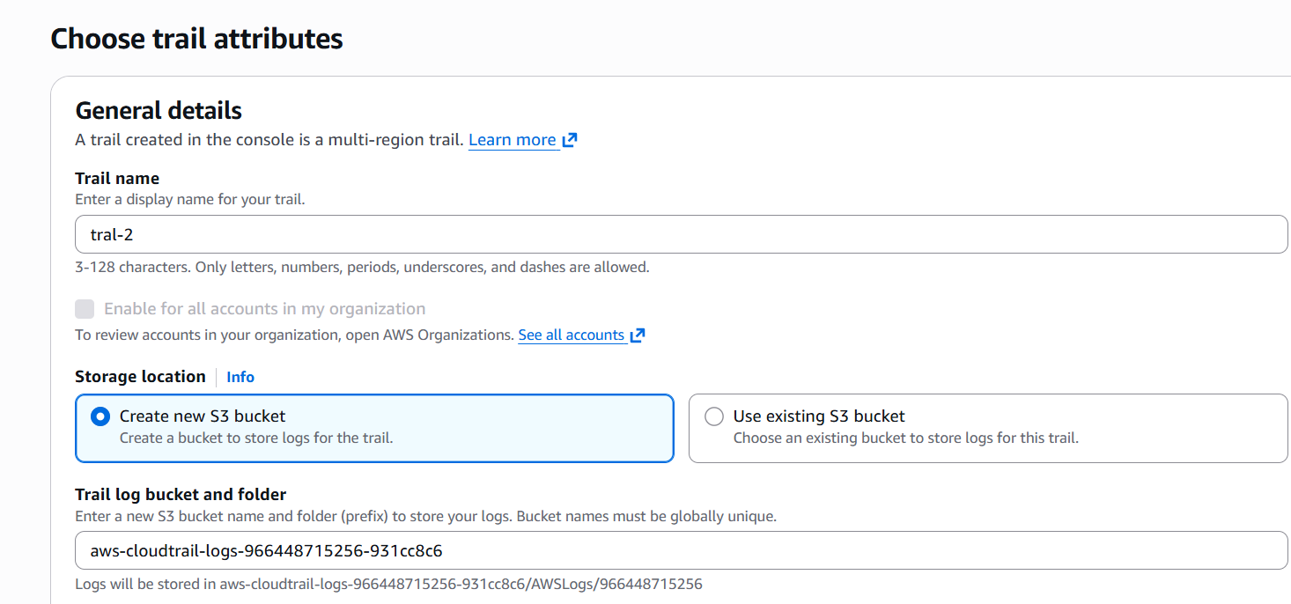
- Selected storage location s3 bucket (create a new one), enabled CloudWatch logs, new log groups and new IAM role
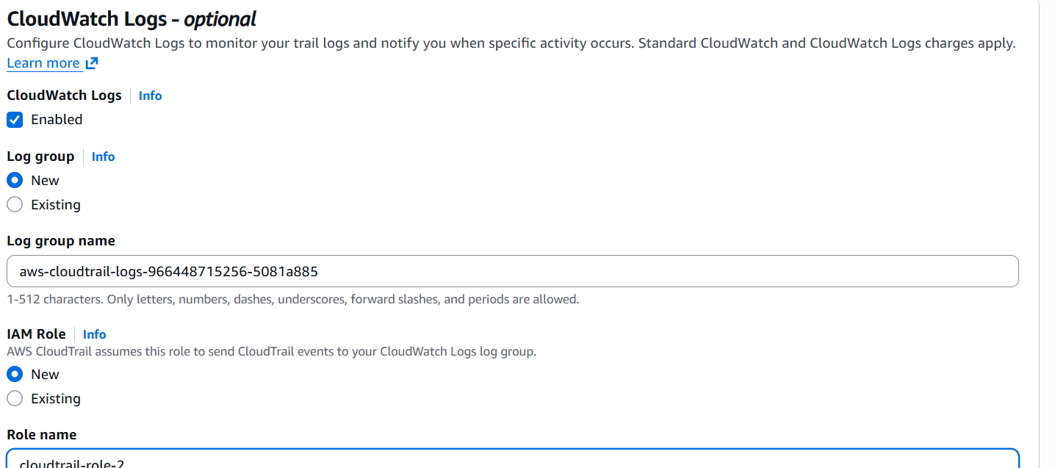
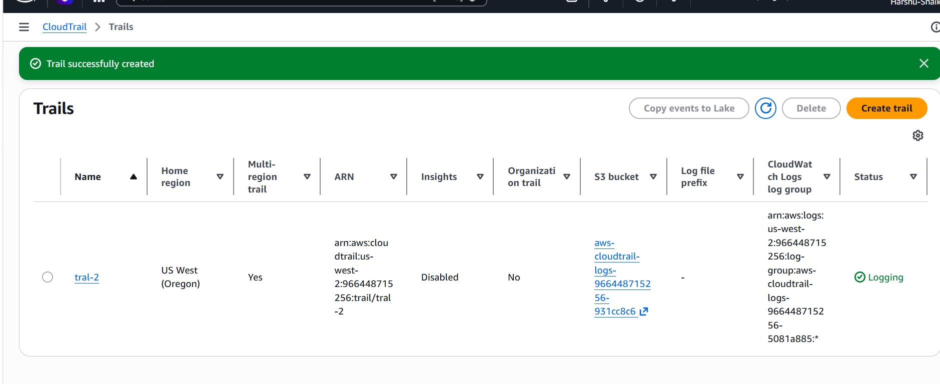
- Checked the log events it came.
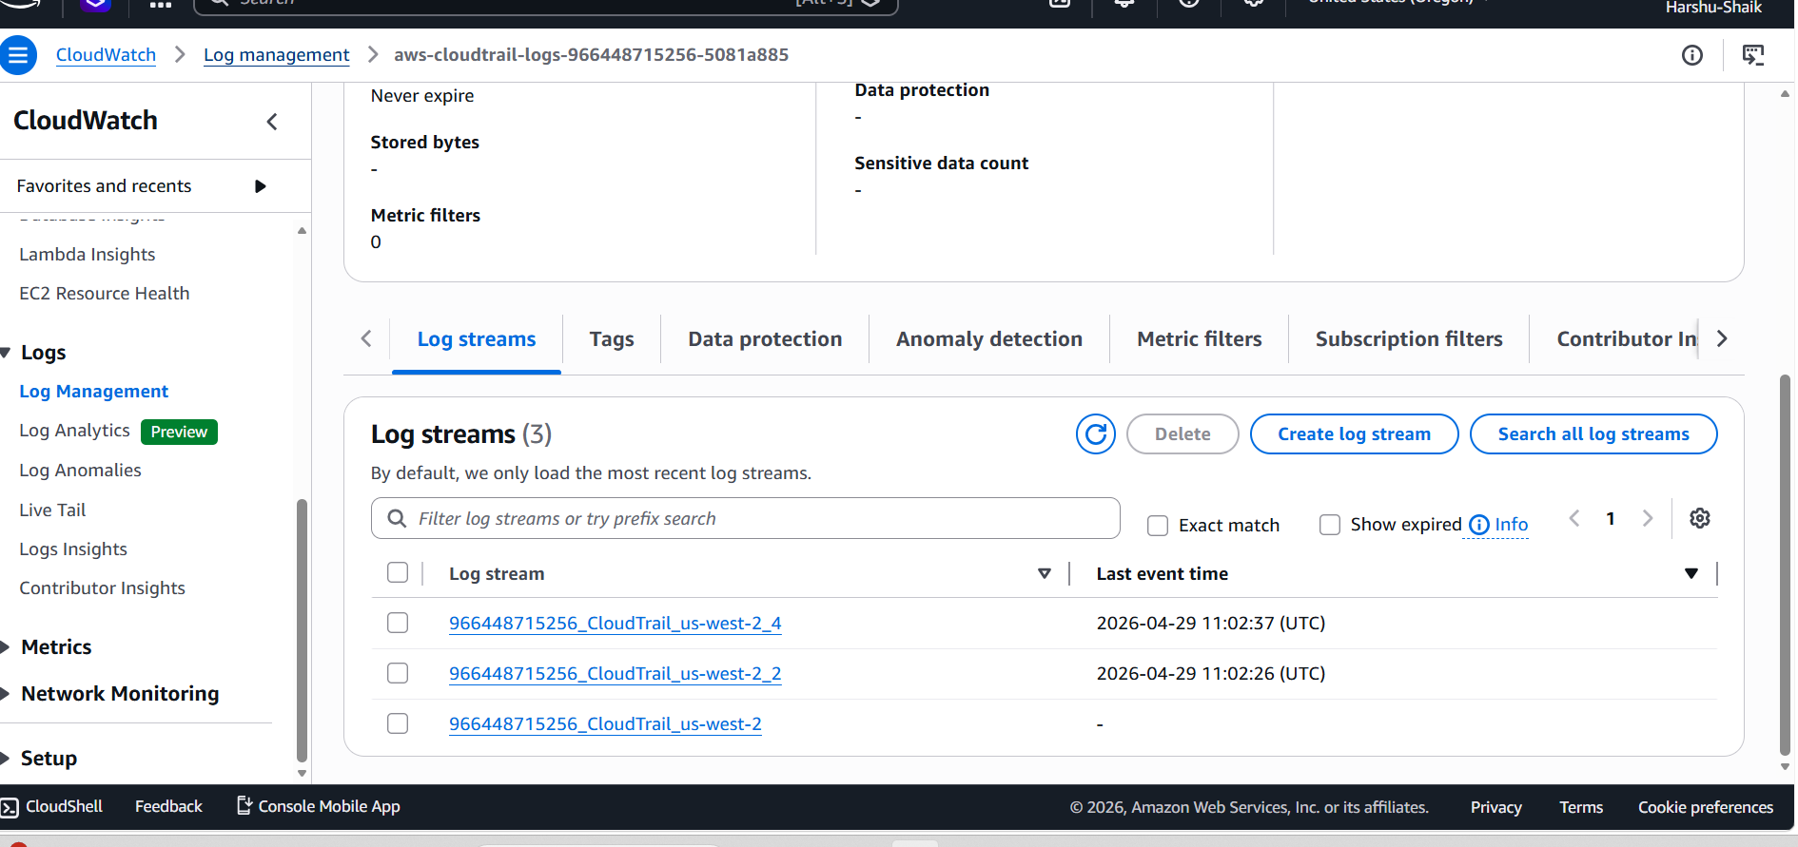
2. Enable SNS for CloudTrail to send alerts via email
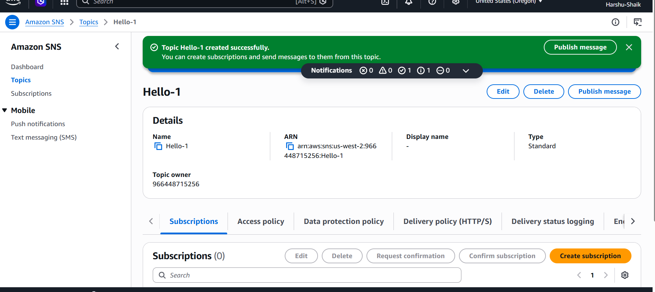
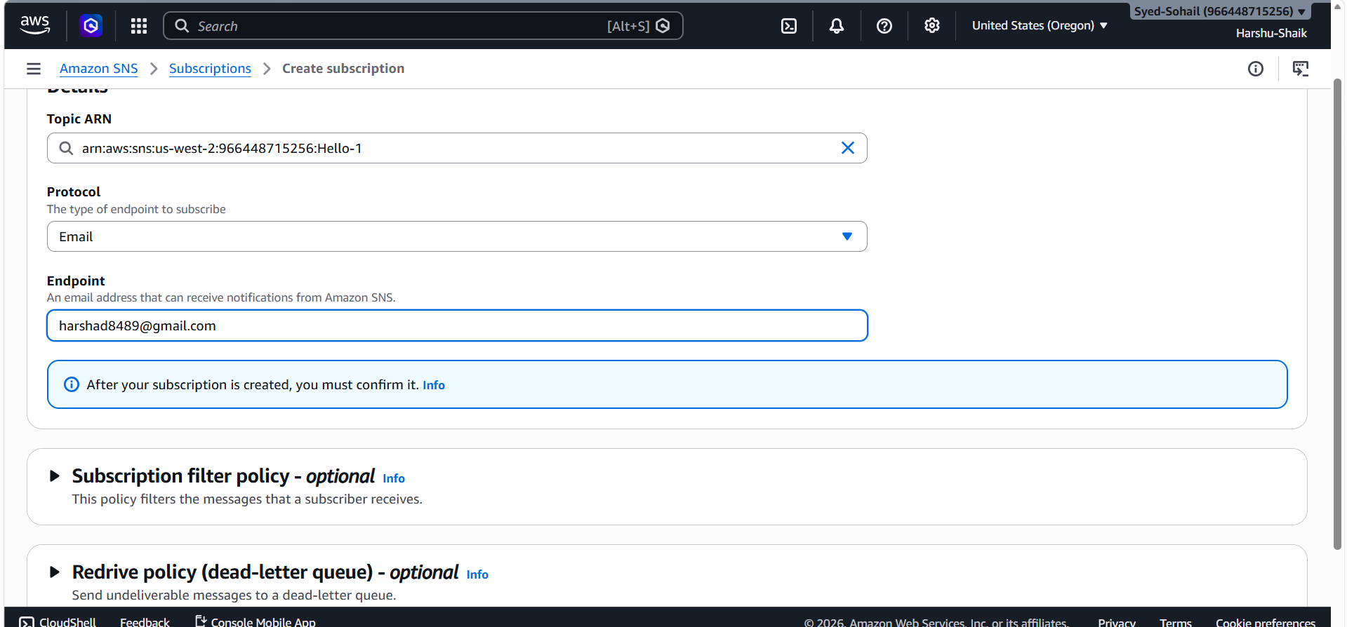
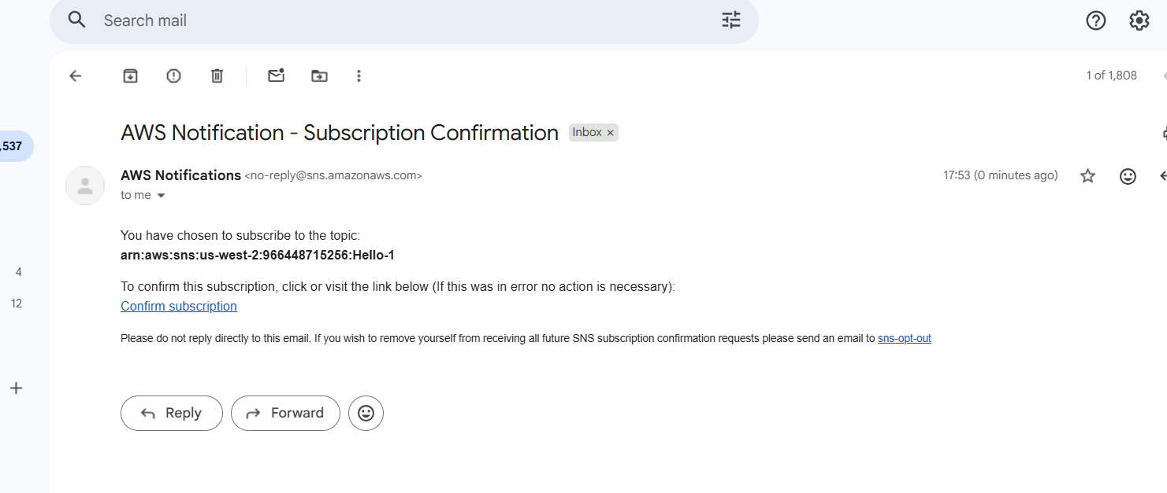
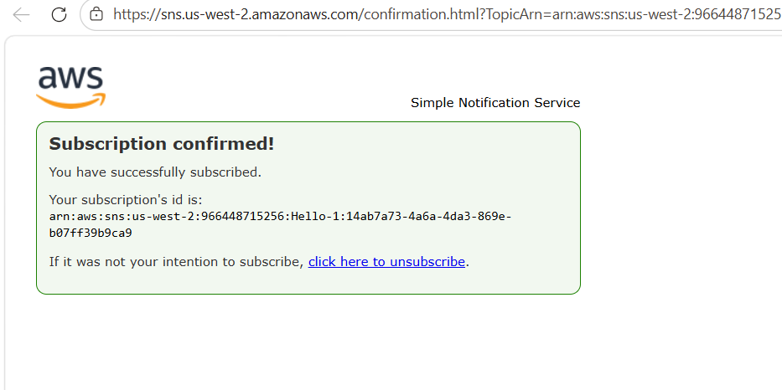
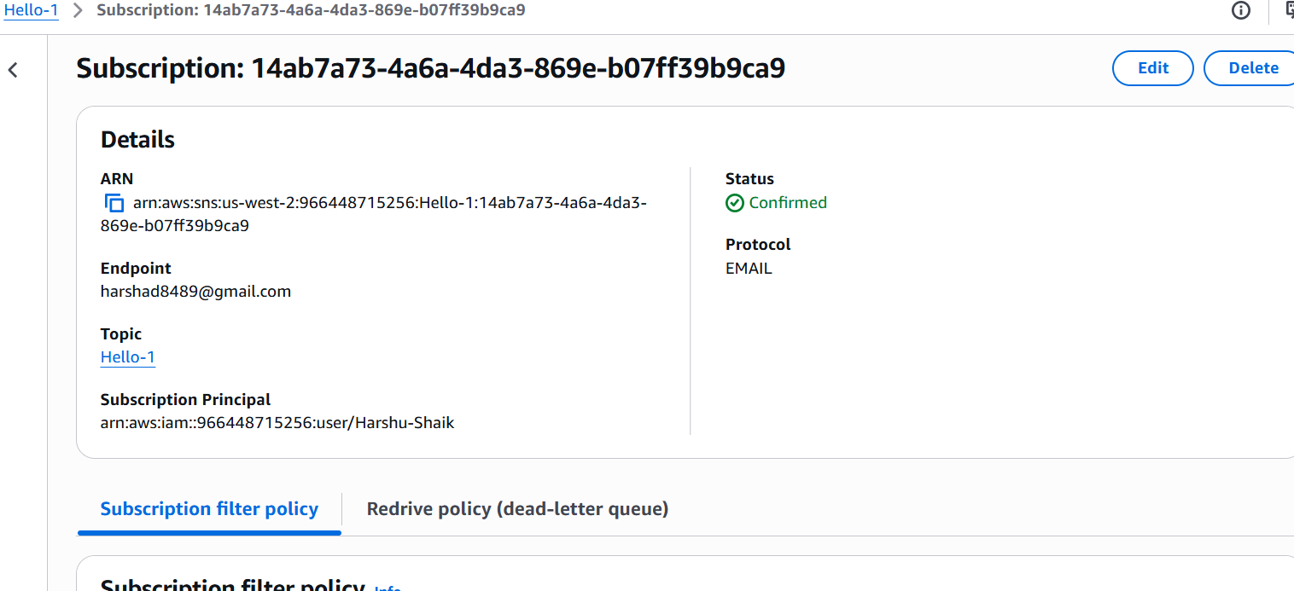
3.Configure CloudWatch monitoring and record the CPU utilization and other metrics of EC2.
Go to cloudwatch >>click on metrics >> choose ec2 >> click on pre instance metric
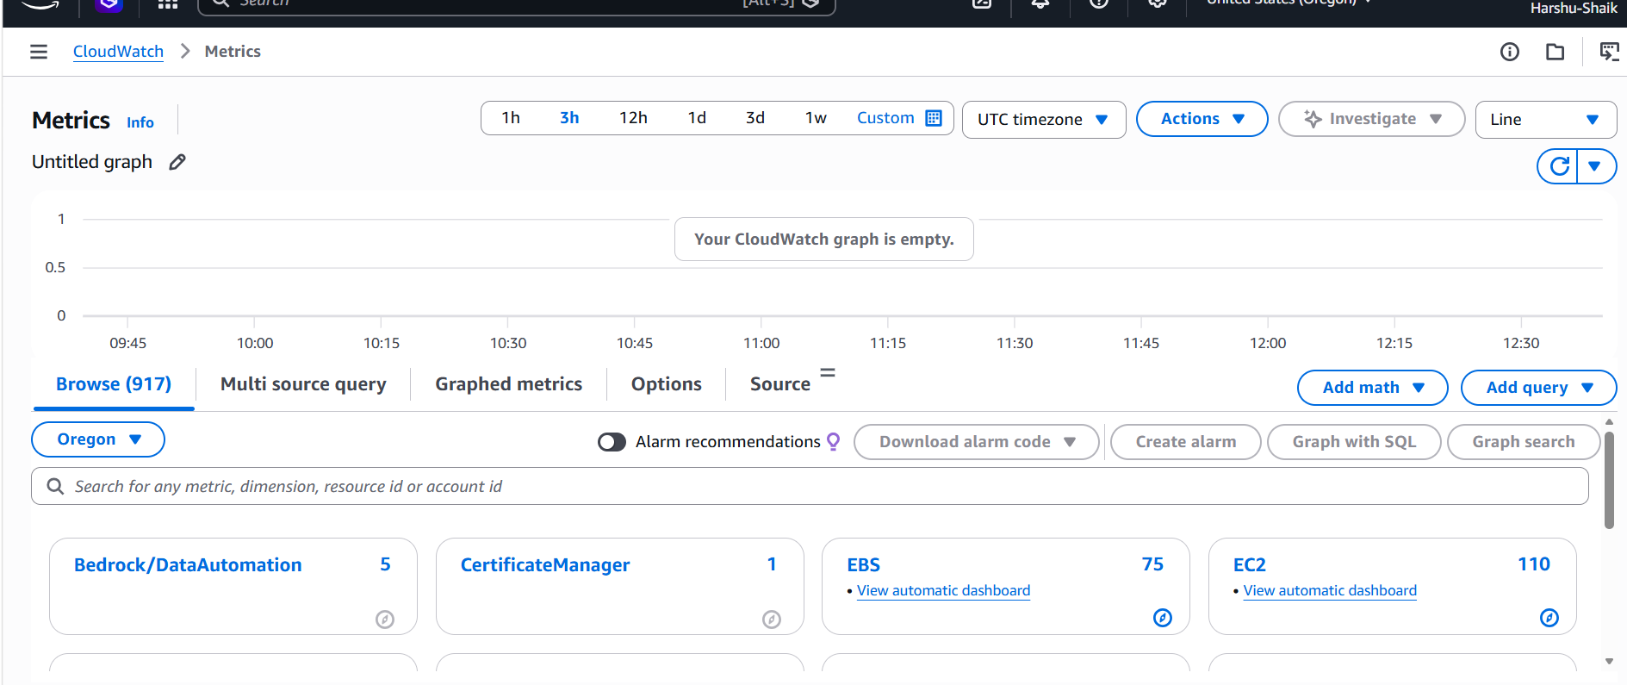
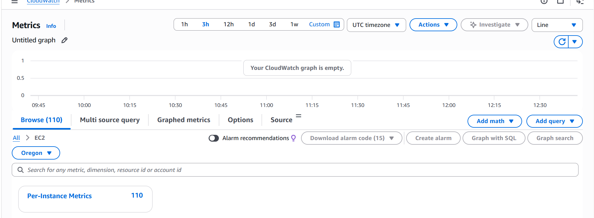
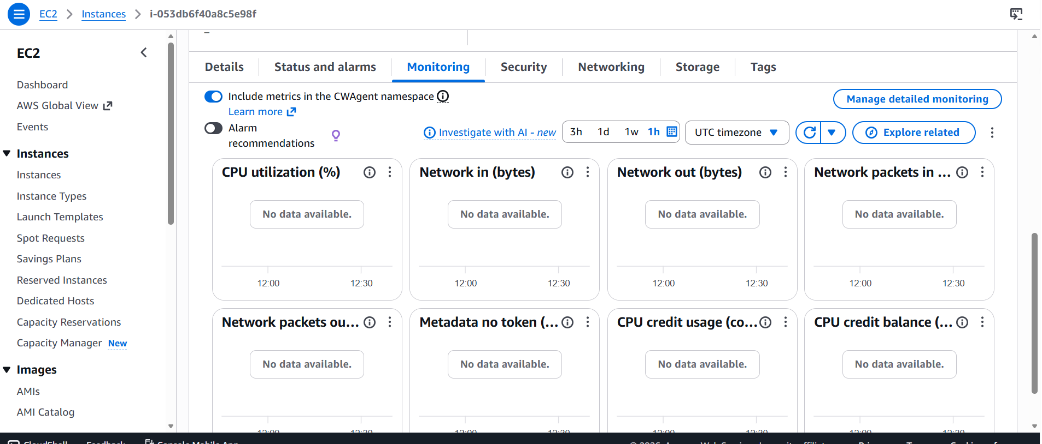
4. Create one alarm to send an alert to email if the CPU utilization is more than 70percent
Go to cloudwatch >> click on Alarm >>create alarm
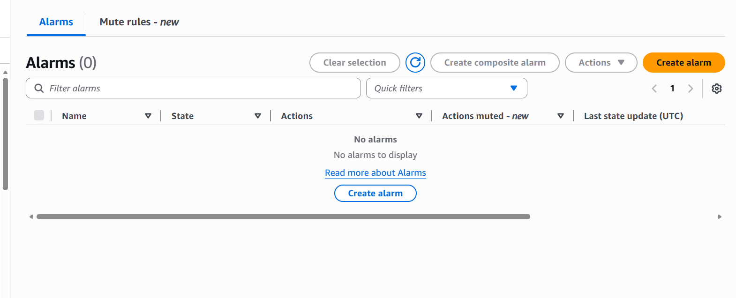
Choose per instance metrics
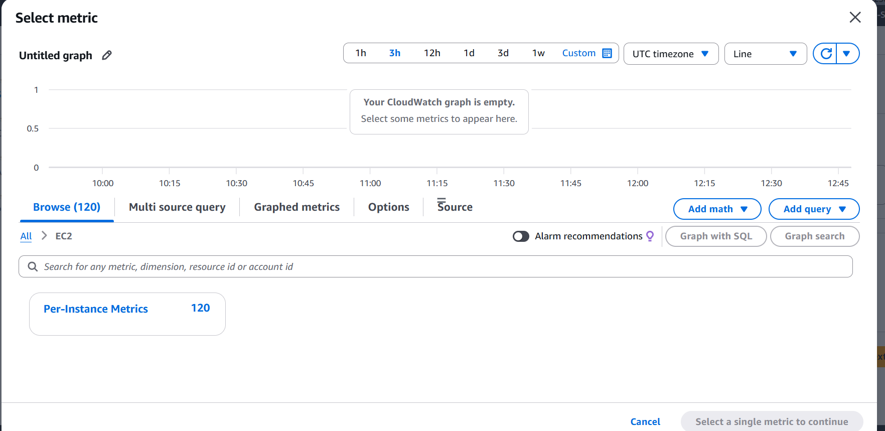
Select CPU utilization and click on select metric
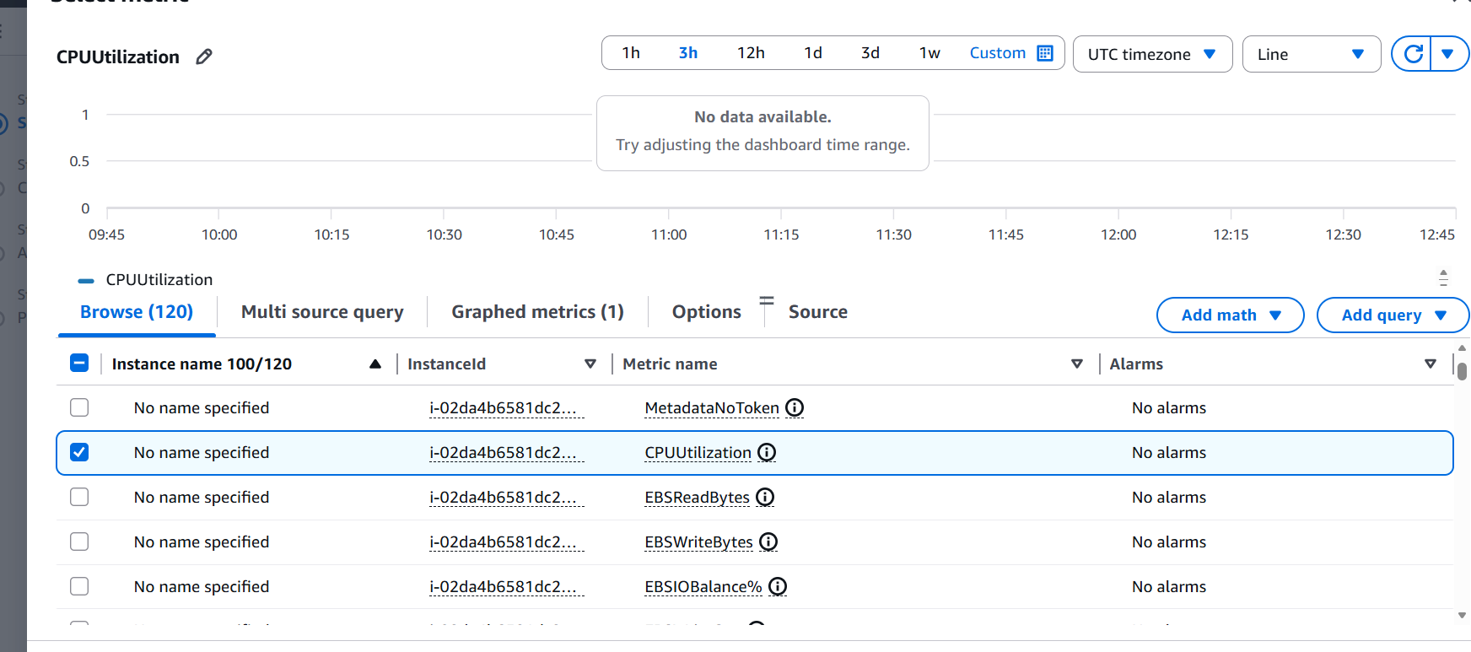
To set the alarm condition.
Configured:
- Statistic = Average
- Period = 5 minutes
- Threshold type = Static
- Whenever CPUUtilization is = Greater than
- than… = 70
- If average CPU usage is above 70% for 5 minutes, alarm triggers
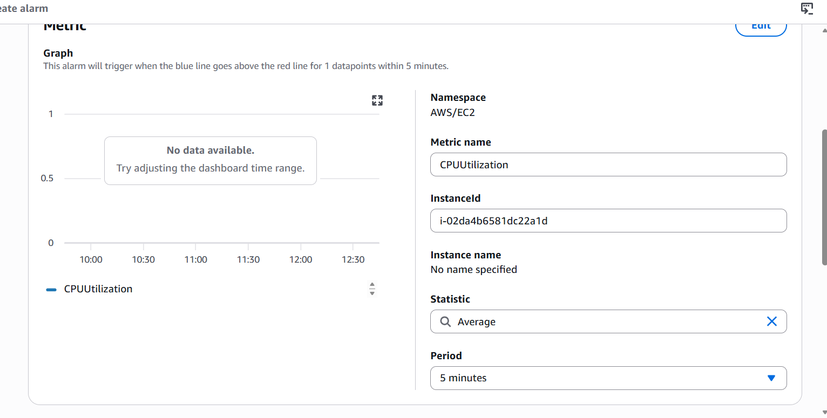
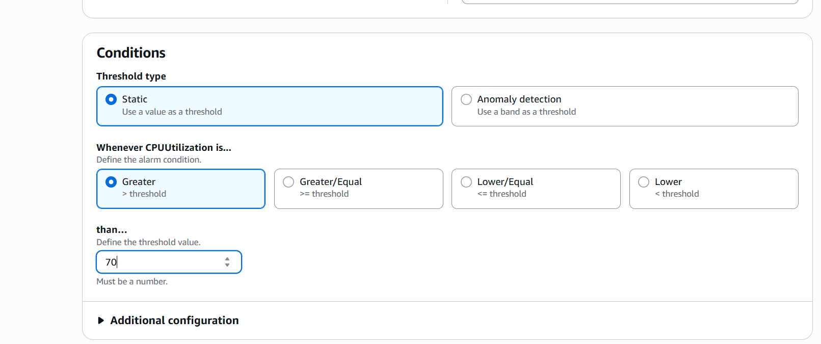
Here I have configured notification
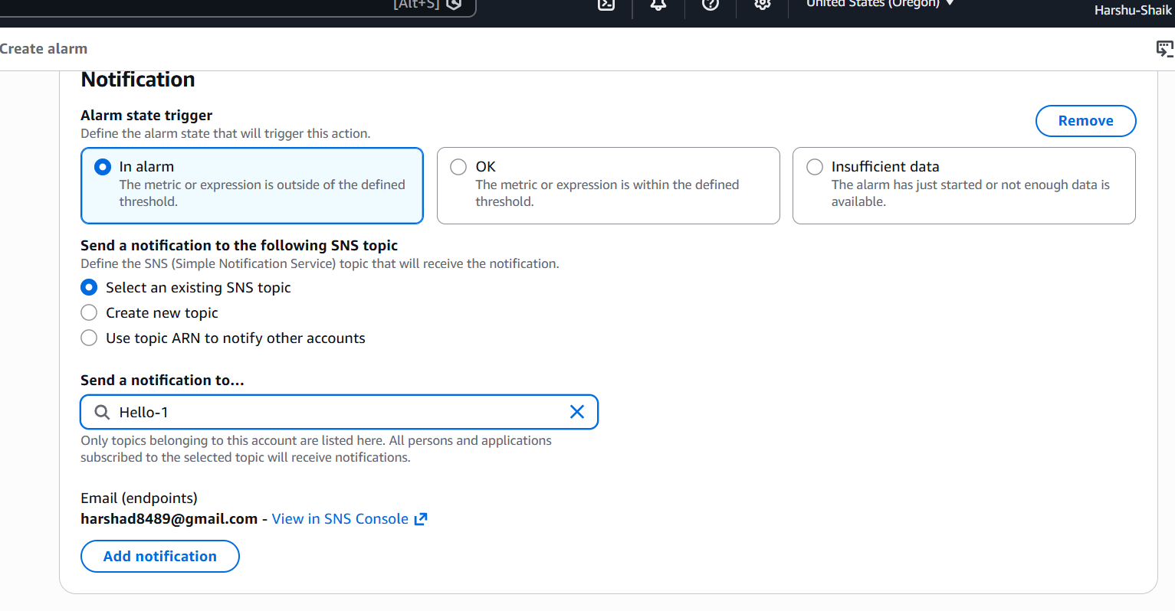
I have added alarm name
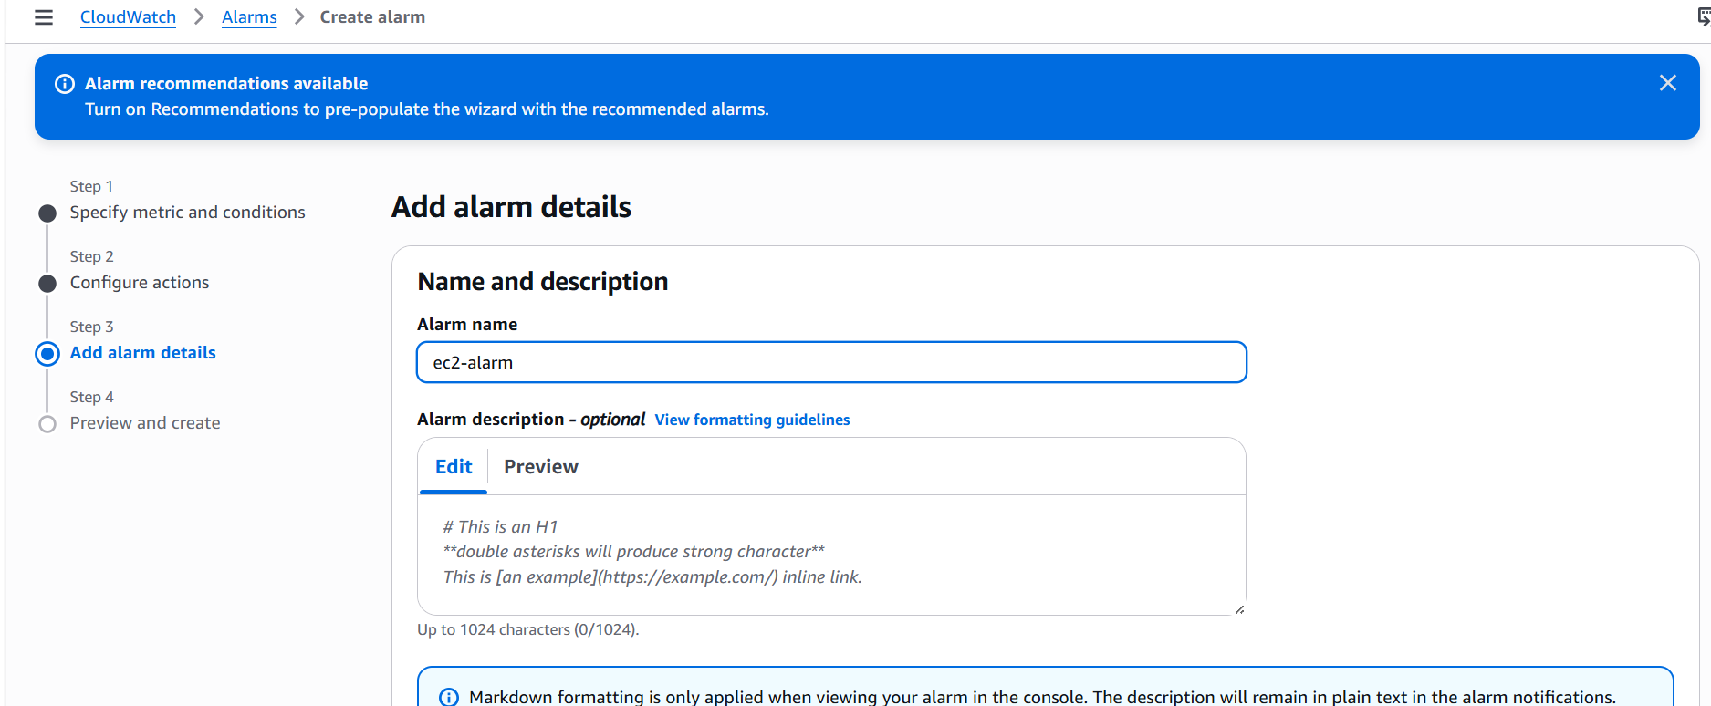
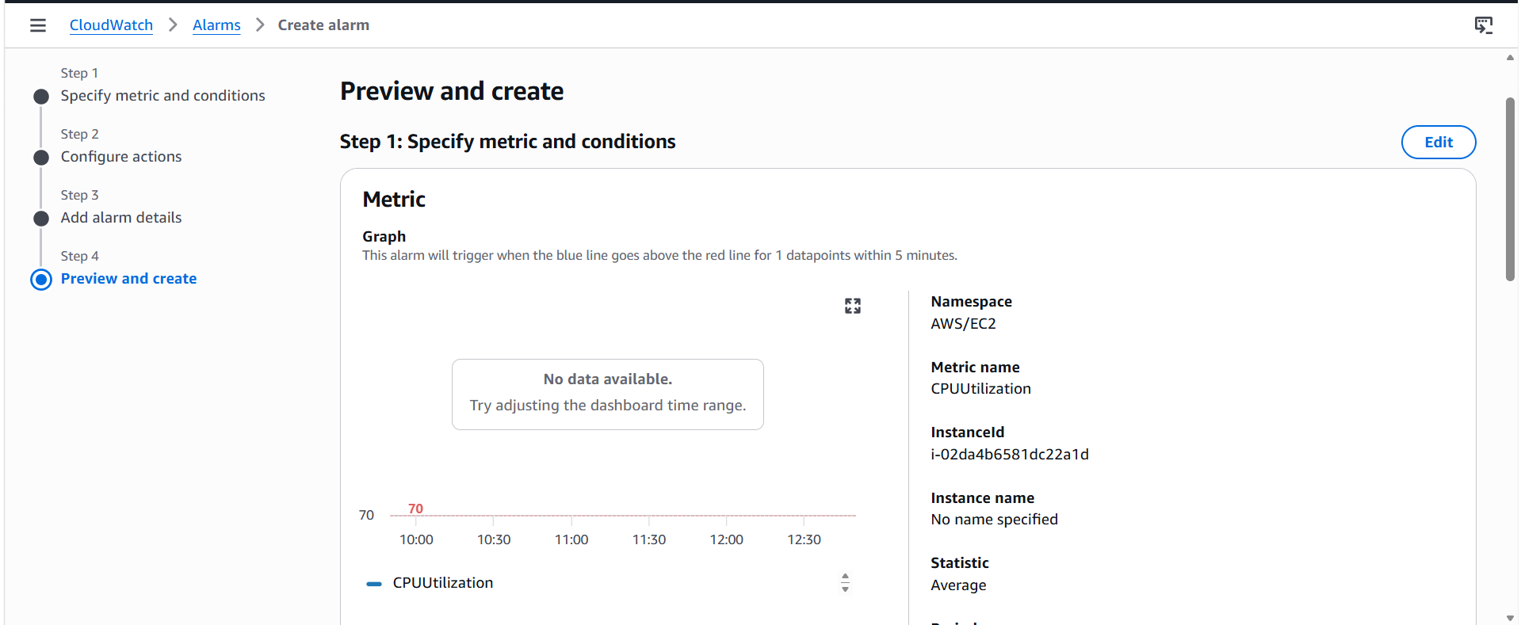
5.Create a Dashboard and monitor the Tomcat service whether it is running or not and send the alert.
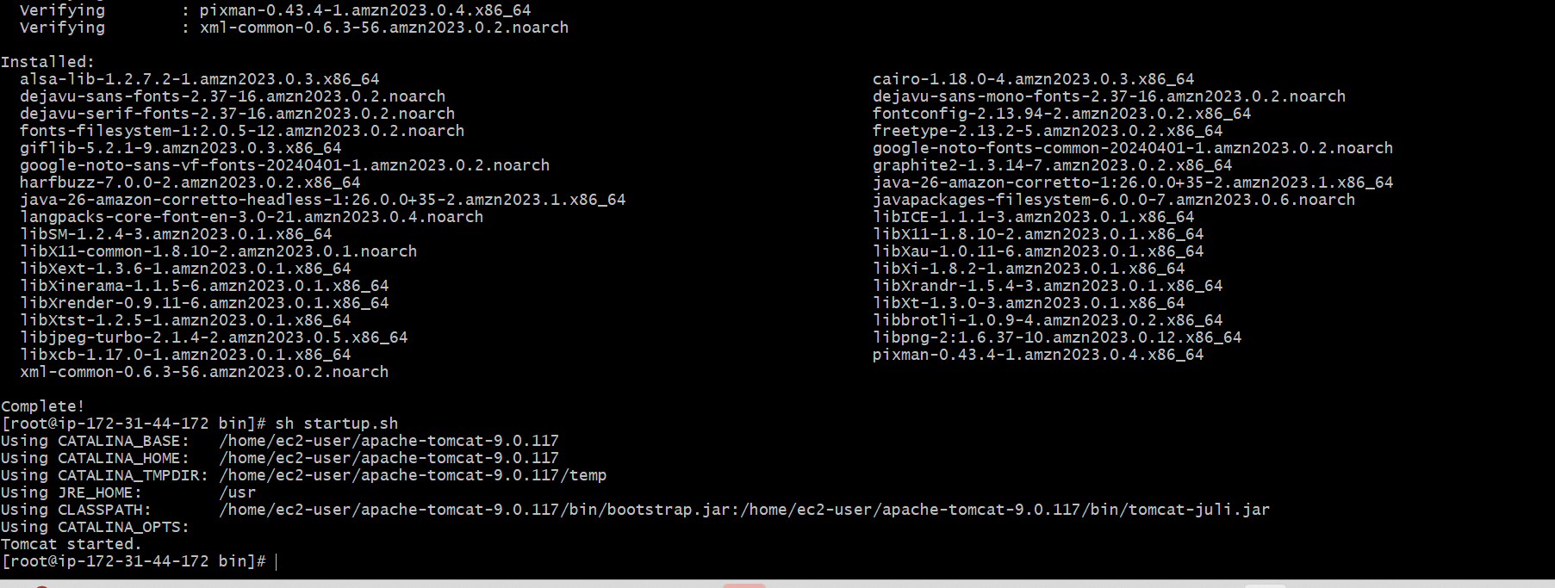
This is script I have used to create a custom metric in cloud
watch ➔
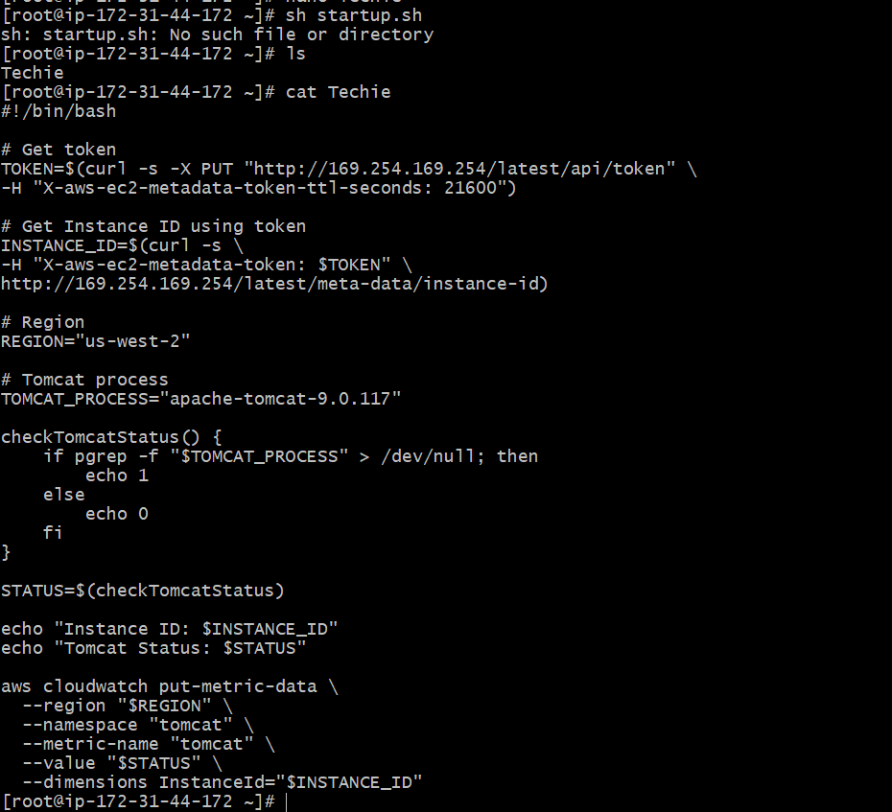
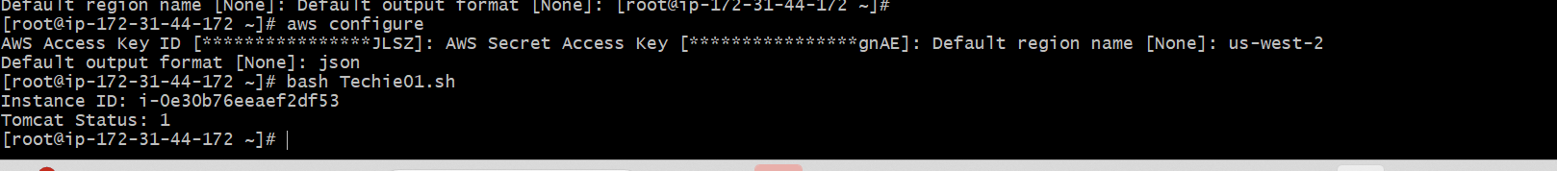
Now I have create the custom metrics for Tomcat Let’s create a alarm if the service get stopped For that >>Go To Alarm Option in Cloud watch >> Create a alarm
Created Two alarm one when it’s not working and another
when it’s working
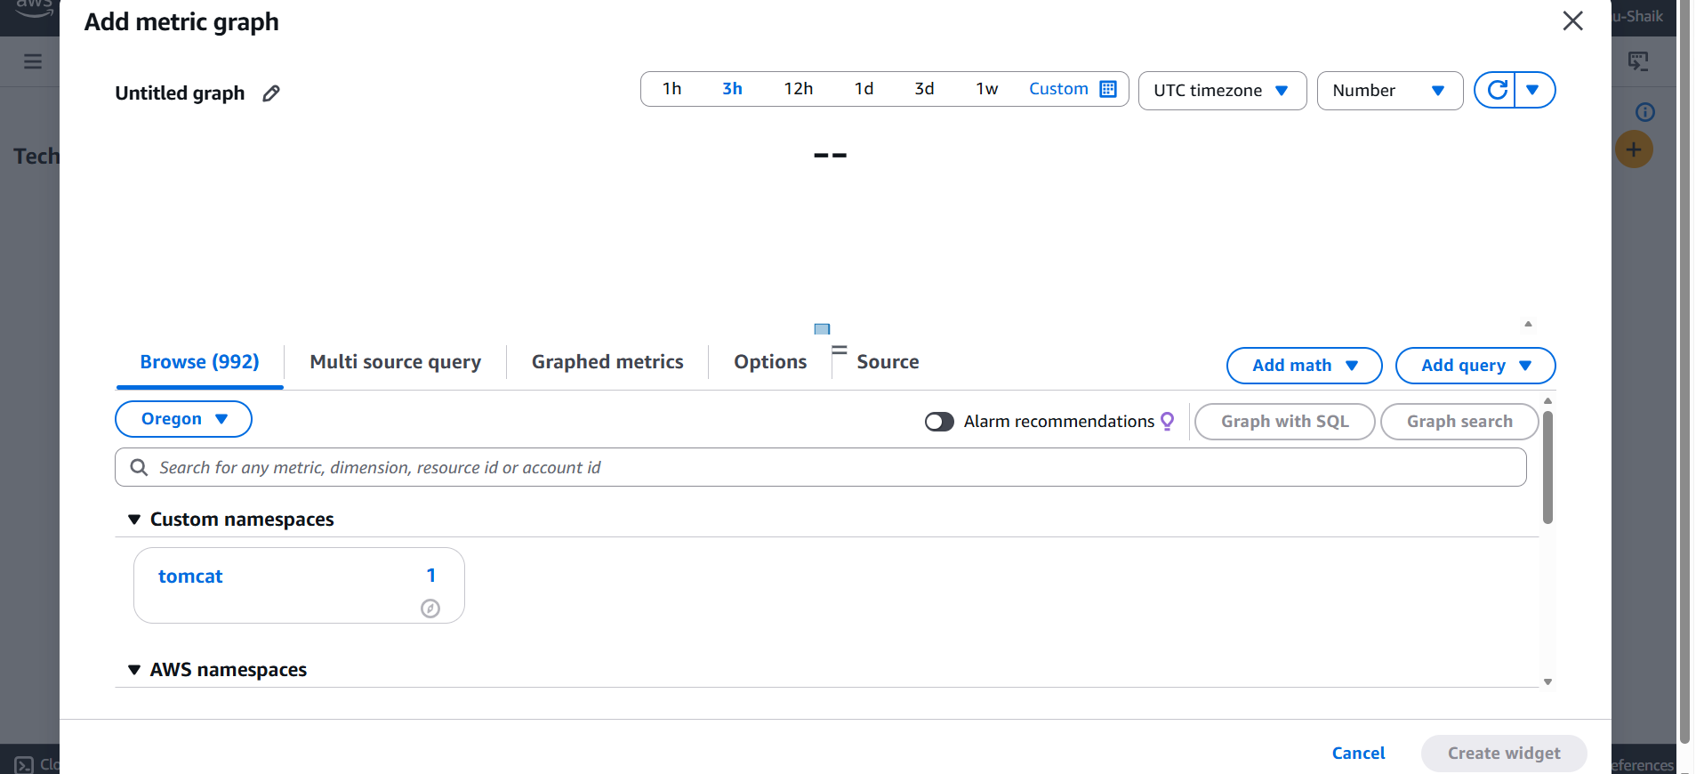
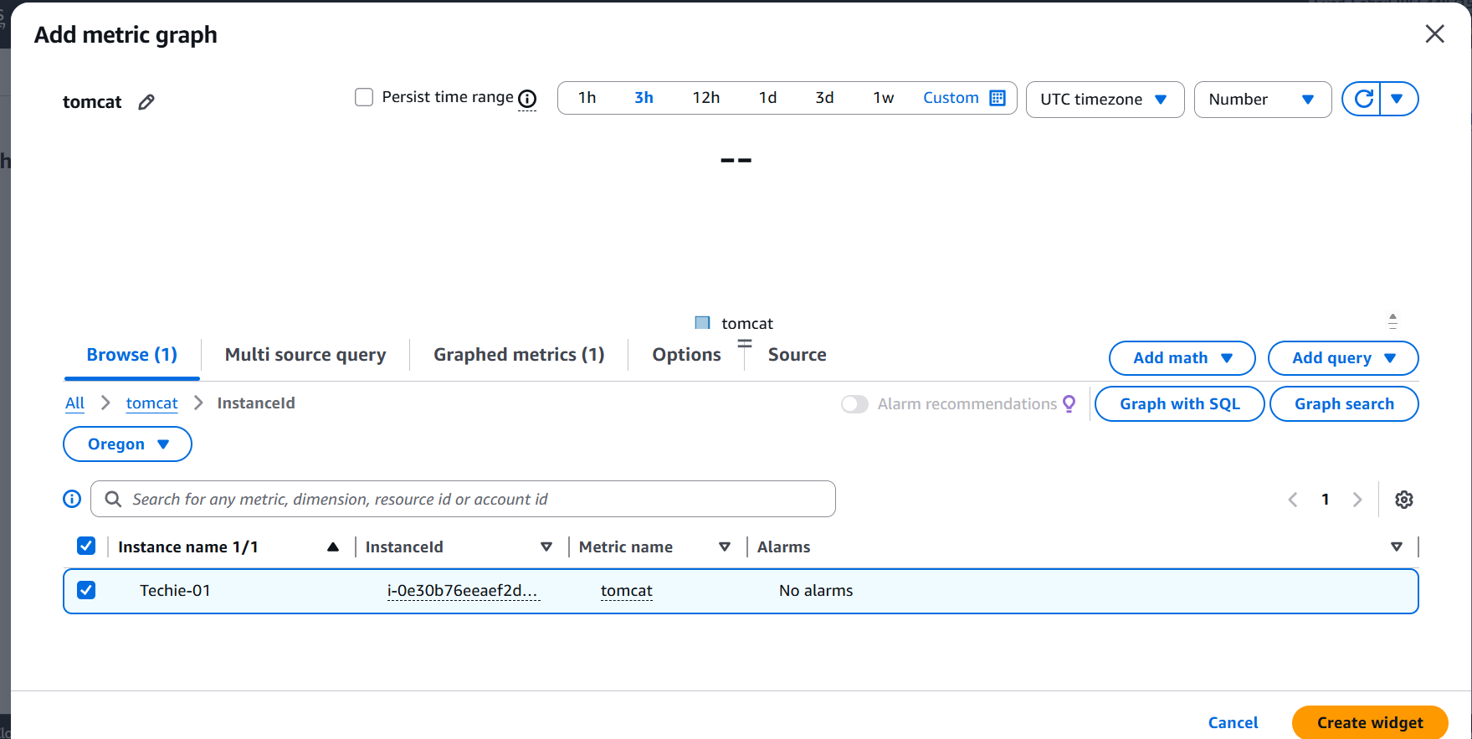
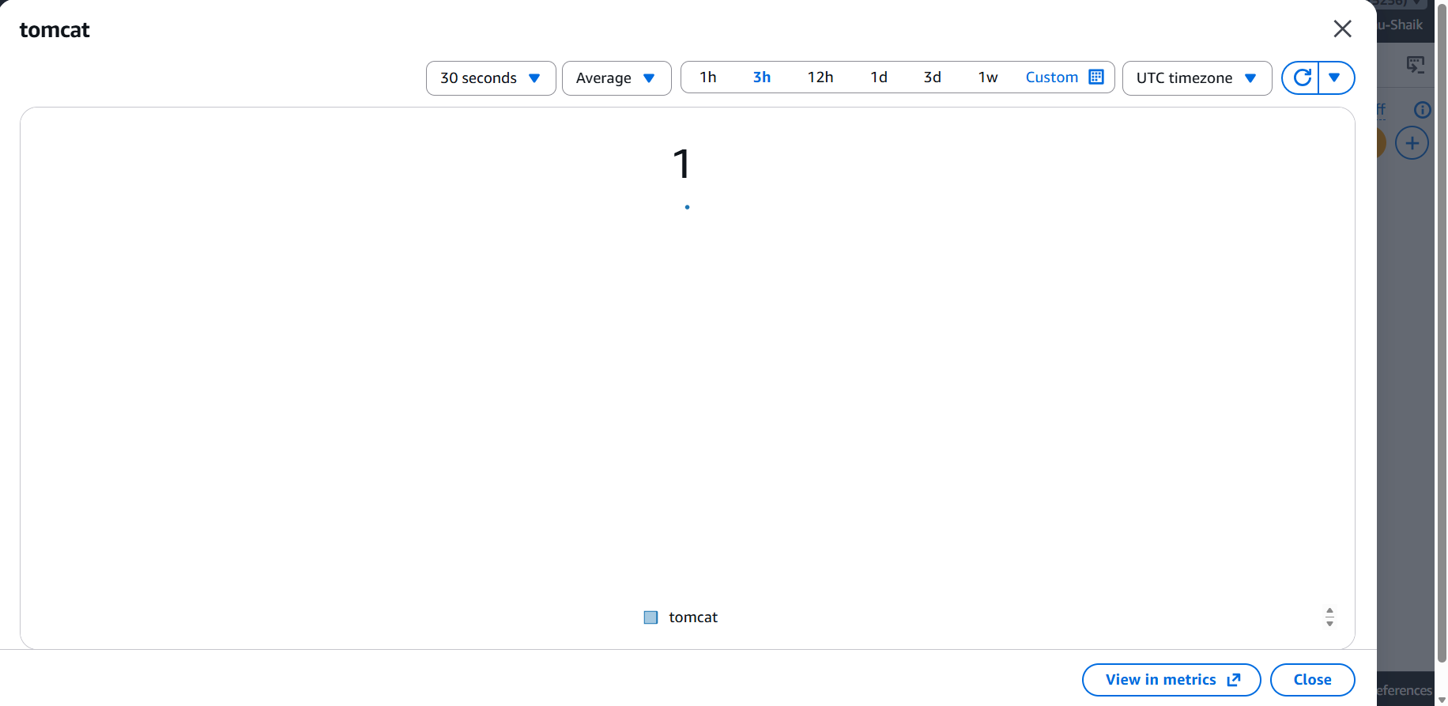
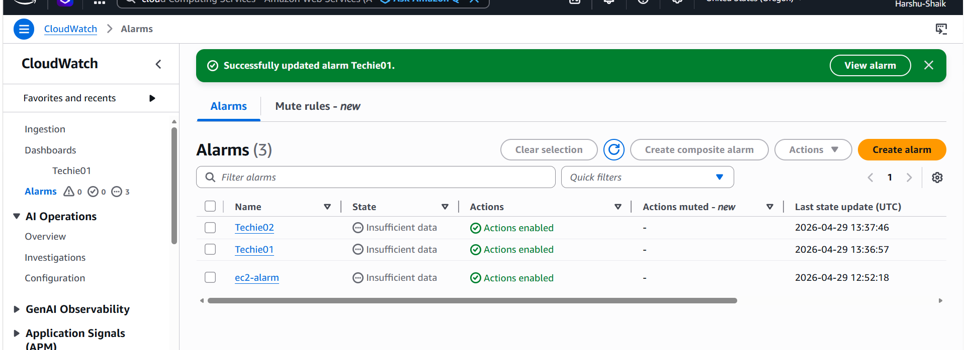
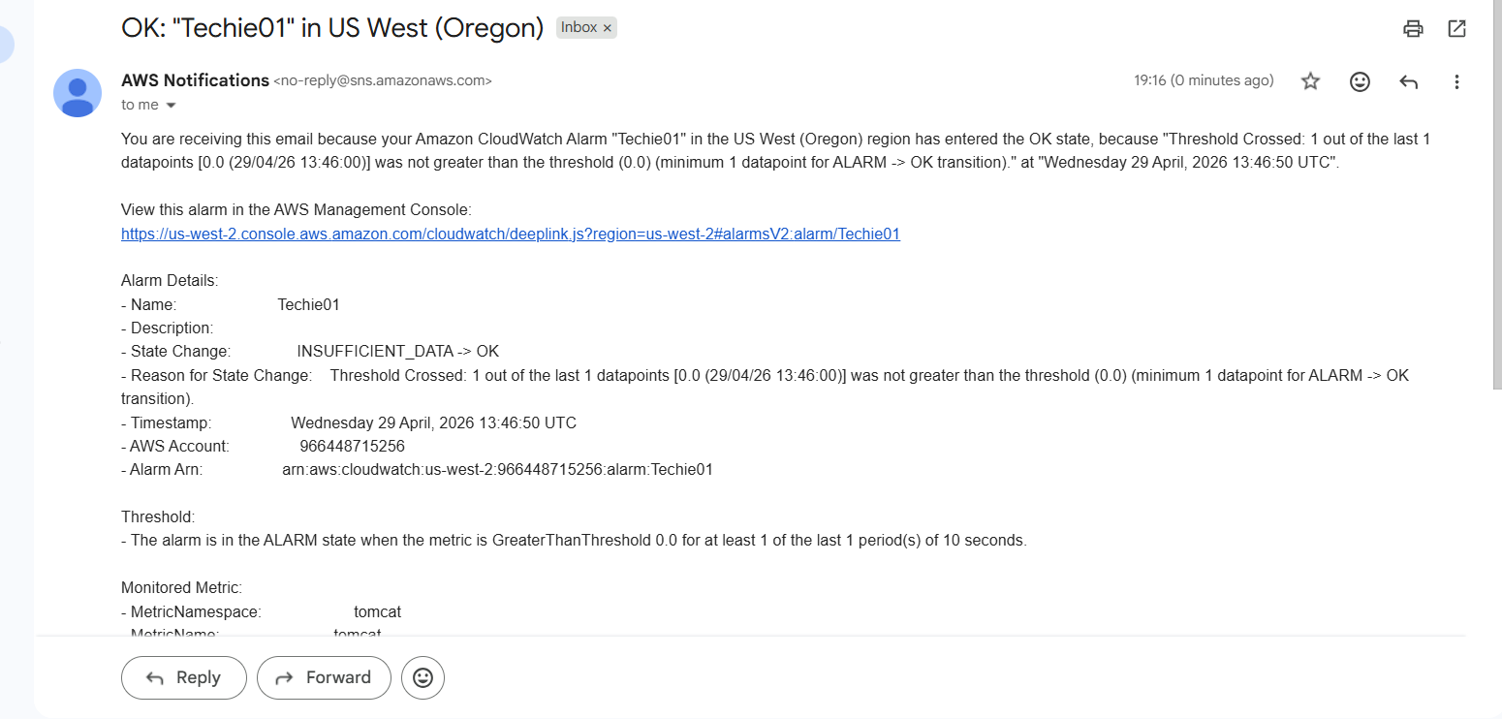
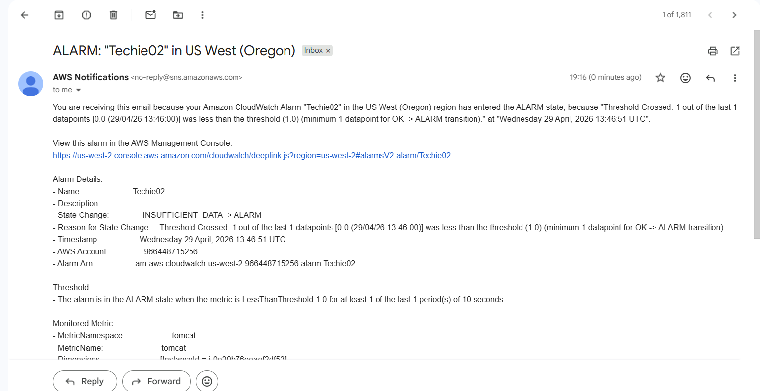
6.Create a Dashboard and monitor the Nginx service to send the alert if Nginx is not running.
install nginx and check the status >>In the server
Create script Like previous one >> and paste below

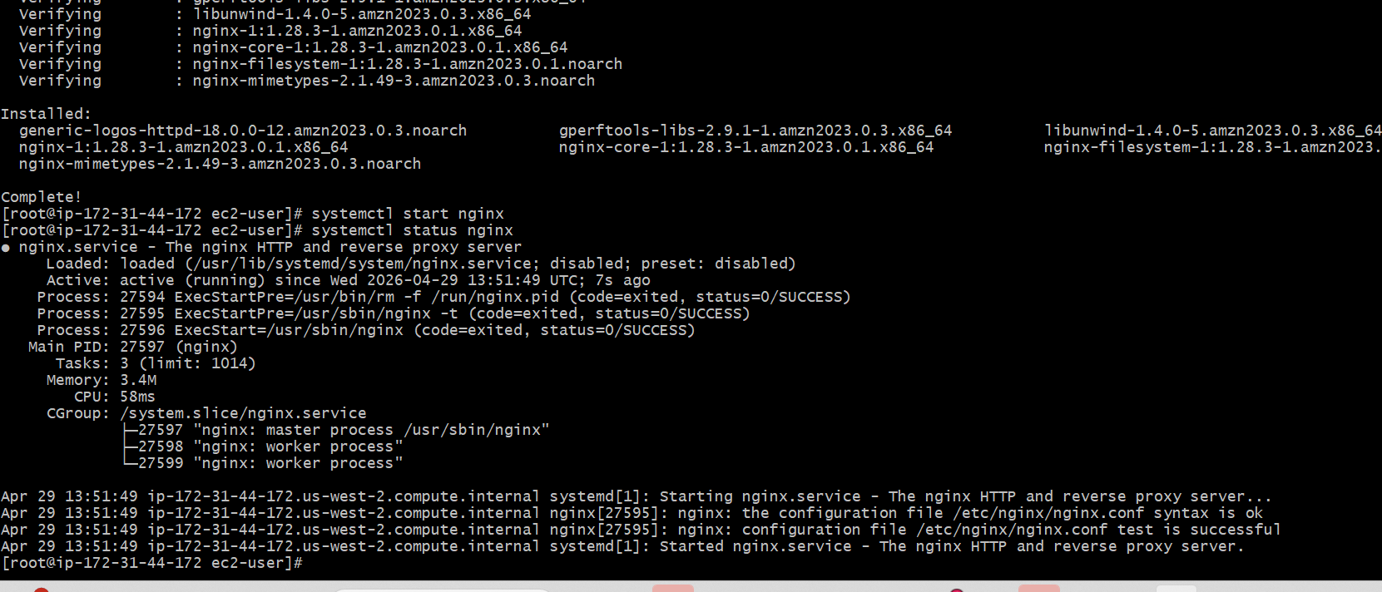
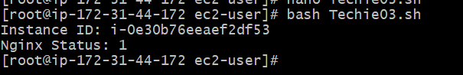
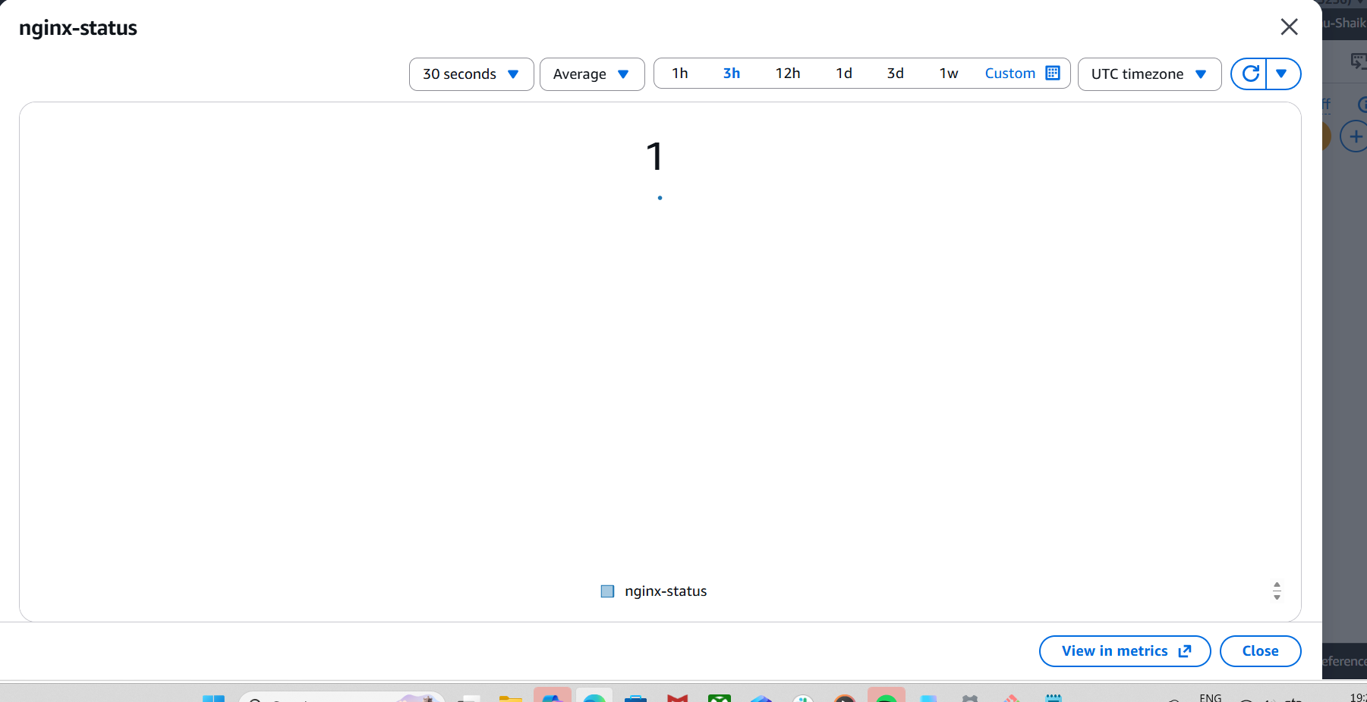
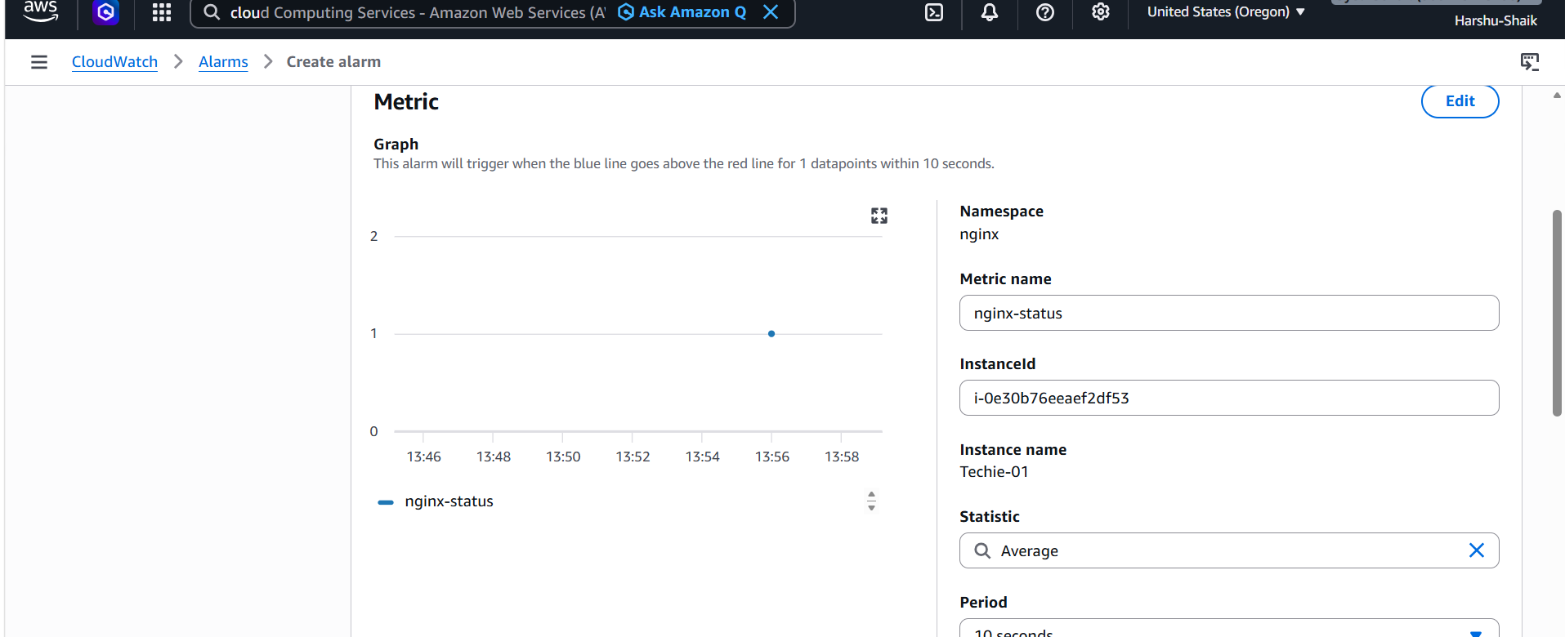
I have received the mail also
